AccessX_Dev
A System of Vulnerability Scanner

Submitted By

Student Name | Student ID
Rakib Hassan | 0242220005101554

MINI LAB PROJECT REPORT
This Report Presented in Partial Fulfillment of the course for
Web Engineering Lab (CSE416)
Computer Science and Engineering Department



DAFFODIL INTERNATIONAL UNIVERSITY
Dhaka, Bangladesh
December 16, 2025

DECLARATION
We hereby declare that this lab project has been done by us under the supervision of Nazia Nuzhat, Lecturer, Department of Computer Science and Engineering, Daffodil International University. We also declare that neither this project nor any part of this project has been submitted elsewhere as lab projects.

Submitted To:

Nazia Nuzhat
Lecturer
Department of Computer Science and Engineering Daffodil International University

Submitted by

Rakib Hassan
ID:0242220005101554
Dept. of CSE, DIU

COURSE & PROGRAM OUTCOME

The following course has course outcomes as follows:

Table 1: Course Outcome Statements
CO’s | Statements
CO1 | Analyze and define system components, interactions, and architectural relationships required to solve web-based engineering problems.
CO2 | Apply web technologies, backend integration, and server-side programming concepts to engineer secure and functional web systems.
CO3 | Analyze and interpret system models, workflows, and architectural designs to represent complex web engineering solutions.
CO4 | Develop and evaluate solutions for complex real-world problems through system integration, security logic, and ethical engineering practices aligned with industry standards.

Table 2: Mapping of CO, PO, Blooms, KP and CEP
CO | PO | Blooms | KP | CEP
CO1 | PO1 | C1, C2 | KP3 | EP1, EP3
CO2 | PO2 | C2 | KP3 | EP1, EP3
CO3 | PO3 | C4, A1 | KP3 | EP1, EP2
CO4 | PO3 | C3, C6, A3,  P3 | KP4 | EP1, EP3

The mapping justification of this table is provided in section 4.3.1, 4.3.2 and 4.3.3.

Table of Contents

Contents
Submitted By 1
DAFFODIL INTERNATIONAL UNIVERSITY 1
DECLARATION 2
COURSE & PROGRAM OUTCOME 2
Table of Contents 3
Introduction 5
1.1 Introduction 5
1.2 Background Study 6
1.3 Motivation 6
1.4 Objectives 6
1.5 Feasibility Study 7
1.6 Gap Analysis 7
1.7 Project Outcome 7
Proposed Methodology/Architecture 8
2.1 Requirement Analysis & Design Specification 8
2.2 Overall Project Plan 12
Implementation and Results 13
3.1 Implementation 13
Section 3.1.1 — Backend Integration Workflow 13
3.2 Performance Analysis 14
3.3 Results and Discussion 15
Engineering Standards and Mapping 17
4.1 Impact on Society, Environment and Sustainability 17
4.2 Project Management and Teamwork 18
4.3 Complex Engineering Problem 18
Conclusion 20
5.1 Summary 20
5.2 Limitation 20
5.3 Future Work 20
References 21

Chapter 1

Introduction

This chapter introduces the background, motivation, objectives, and feasibility of the proposed system titled “AccessX_Dev: A System of Vulnerability Scanner.” It outlines the problem context, highlights existing limitations in current solutions, and establishes the necessity of a controlled, ethically designed web-based security assessment platform from a Web Engineering perspective.

Introduction
The rapid growth of web-connected devices, remote services, and cloud-based infrastructures has significantly increased the attack surface of modern computing systems. Organizations and individuals increasingly rely on automated security analysis tools to identify misconfigurations, outdated software components, exposed services, and potential vulnerabilities within their devices and networks. Modern vulnerability assessment platforms such as Shodan, Nessus, and similar reconnaissance tools demonstrate how device metadata, service exposure, and configuration information can be analyzed to assess security posture [3], [9]. However, these systems operate under strict legal, ethical, and authorization constraints due to their potential misuse if exposed as unrestricted public services. From a Web Engineering standpoint, designing such systems involves more than building a functional website [6], [7]. It requires architectural planning, controlled access mechanisms, backend service integration, secure data handling, ethical safeguards, and compliance-aware deployment strategies. Therefore, the focus of this project is not the creation of a public vulnerability scanning website, but the engineering of a controlled security analysis system that is presented through a web-based interface for authorized and supervised usage.

Background Study

System / Tool | Core Functionality | Deployment Model | Limitations
Shodan | Internet-wide device and service discovery | Authorized public platform | Requires strict access control
Nessus | Vulnerability scanning and compliance checks | Local / enterprise | Not web-integrated by default
Seeker-like Tools | Device reconnaissance and metadata extraction | Local execution | Cannot be publicly hosted
AccessX_Dev (Proposed) | Integrated vulnerability analysis via web system | Controlled, supervised environment | Limited to authorized use

Table 1.1: Background Study of Existing Vulnerability Analysis Systems

Motivation
The primary motivation of this project arises from the academic gap between conventional web development projects and real-world web engineering systems. While many student projects focus primarily on frontend design and basic backend logic, they often overlook system-level engineering considerations such as security workflows, ethical constraints, controlled exposure, and responsible integration of powerful backend tools. This project was motivated by the need to demonstrate that complex security-oriented systems can be engineered responsibly using web technologies. By integrating existing vulnerability analysis tools into a controlled PHP-based web framework, the project emphasizes system design, architectural decision-making, and ethical compliance rather than tool creation or misuse.

Objectives
The objectives of this project are as follows:
1. To design a controlled web-based system that integrates backend vulnerability analysis tools through secure and authorized workflows.
2. To develop a PHP-based web interface for managing, visualizing, and reporting vulnerability assessment results.
3. To demonstrate the distinction between web development components (user interface, dashboards, reporting) and web engineering components (system architecture, security logic, controlled exposure).
4. To ensure ethical and legal compliance by restricting system access and avoiding public deployment of sensitive security functionalities.
5. To provide an academic demonstration of vulnerability assessment engineering using supervised environments such as local servers and temporary NGROK tunnels.

Feasibility Study

A feasibility study was conducted by analyzing existing security assessment platforms, research literature, and practical deployment models. Tools such as Shodan and enterprise vulnerability scanners demonstrate that device-level security analysis is feasible only under controlled and authorized environments [1], [10]. From a technical perspective, the project is feasible due to the availability of stable backend tools, PHP-based server technologies, local database systems, and secure tunneling services such as NGROK for demonstration purposes. From an academic perspective, the project aligns with Web Engineering principles by focusing on system integration, workflow design, and ethical safeguards rather than low-level exploit development.

Gap Analysis

Existing systems either function as fully authorized public platforms with strict regulatory oversight or operate as standalone local security tools without web-based integration. Most academic web projects, on the other hand, focus primarily on frontend interfaces and lack meaningful engineering depth related to security workflows and system constraints. The identified gap lies in the absence of academically structured projects that demonstrate how powerful security analysis tools can be responsibly engineered into a web-based system without violating ethical or legal boundaries. This project addresses that gap by introducing a controlled architecture where vulnerability analysis services are encapsulated as backend components and exposed to the web interface only under supervised and restricted conditions.

Project Outcome

The outcome of this project is a functional and academically compliant vulnerability scanning system that demonstrates Web Engineering principles through controlled tool integration, secure architecture, and ethical deployment strategies. The system successfully presents vulnerability assessment results through a web interface while maintaining strict access control and avoiding public misuse.

Chapter 2

Proposed Methodology/Architecture
This chapter presents the overall methodology, system architecture, and design specifications of the proposed AccessX_Dev system. It explains how backend security analysis services are engineered into a controlled web-based framework, detailing system components, data flow, access control, and ethical exposure mechanisms.

Requirement Analysis & Design Specification

The design of AccessX_Dev is guided by both functional and non-functional requirements derived from Web Engineering principles and ethical cybersecurity constraints.
Functional requirements include the ability to initiate vulnerability analysis through authorized user actions, collect device-related security data from backend services, store analysis results securely, and present findings through a web-based dashboard.
Non-functional requirements emphasize controlled access, system reliability, data integrity, ethical compliance, and restricted exposure of security-sensitive operations. The system must prevent unauthorized use, avoid public deployment of scanning capabilities, and ensure that all demonstrations occur in supervised or local environments.

Overview

AccessX_Dev follows a layered system architecture where security analysis operations are decoupled from the web interface. Backend tools responsible for vulnerability assessment operate as isolated services, while the PHP-based web server acts as a controller, mediator, and presentation layer.
This separation ensures that powerful security functionalities are never directly exposed to end users or the public internet. Instead, controlled requests are processed internally, and only sanitized results are transmitted to the web interface for visualization and reporting.

Proposed Methodology/ System Design

The proposed system methodology is based on a controlled request–analysis–response workflow [6], [7]. When an authorized user interacts with the web interface, a request is generated and validated by the PHP backend. This request is then forwarded to the backend security analysis services, which may utilize existing vulnerability assessment tools operating within a restricted execution environment.
The backend services perform device analysis, configuration inspection, and metadata extraction without exposing raw scanning capabilities to the web layer. The resulting data is processed, filtered, and stored in a local database. Only summarized and non-exploitable information is returned to the web interface.
For demonstration purposes, the system may be exposed temporarily using NGROK [2], [5], allowing secure tunneling of the local server without deploying the system as a public website. This approach enables live demonstrations under supervision while maintaining ethical and legal compliance.

Figure 2.1: System Architecture of AccessX_Dev
This figure is critical. It visually proves “engineering,” not just UI.

UI Design

The user interface of AccessX_Dev is designed to provide clarity, usability, and structured visualization of security analysis results. The web interface includes authentication screens, a dashboard for viewing analysis summaries, and reporting modules for reviewing vulnerability information.
While the UI enhances usability and presentation, it does not perform any security analysis directly. All vulnerability-related logic is handled by backend services, reinforcing the separation between web development and web engineering responsibilities.

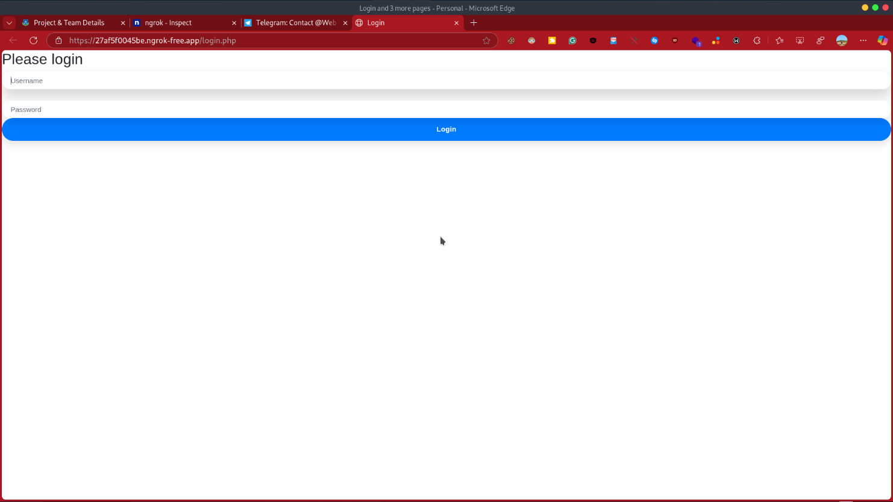
Figure 2.2: Login Interface of AccessX_Dev
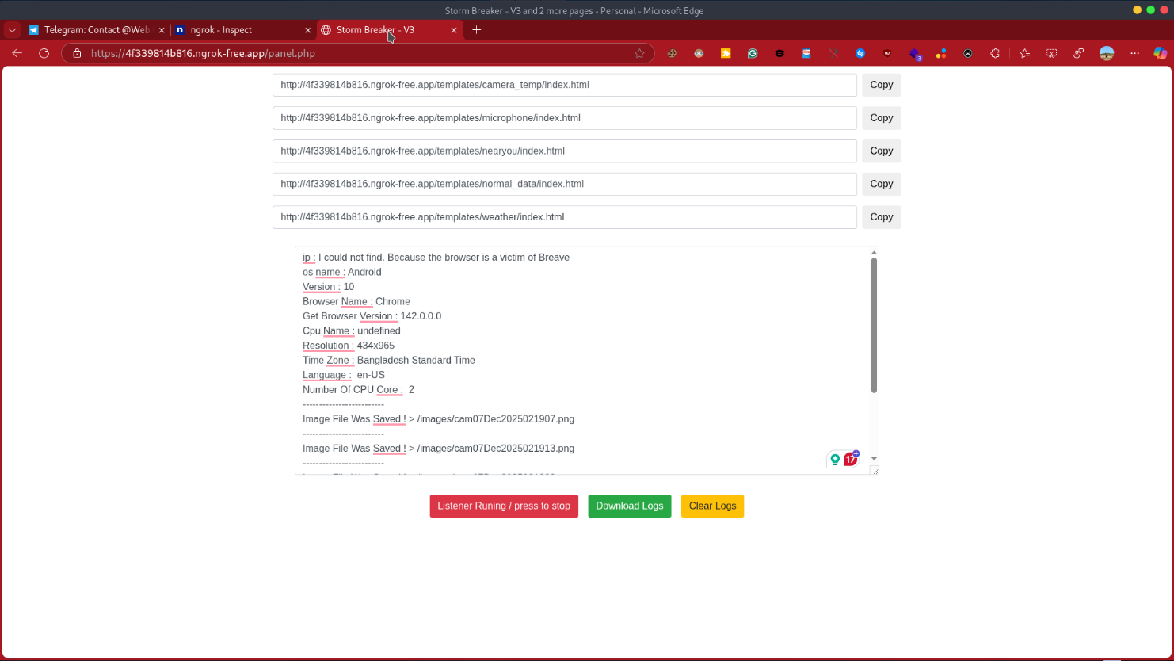
Figure 2.3: Vulnerability Dashboard View
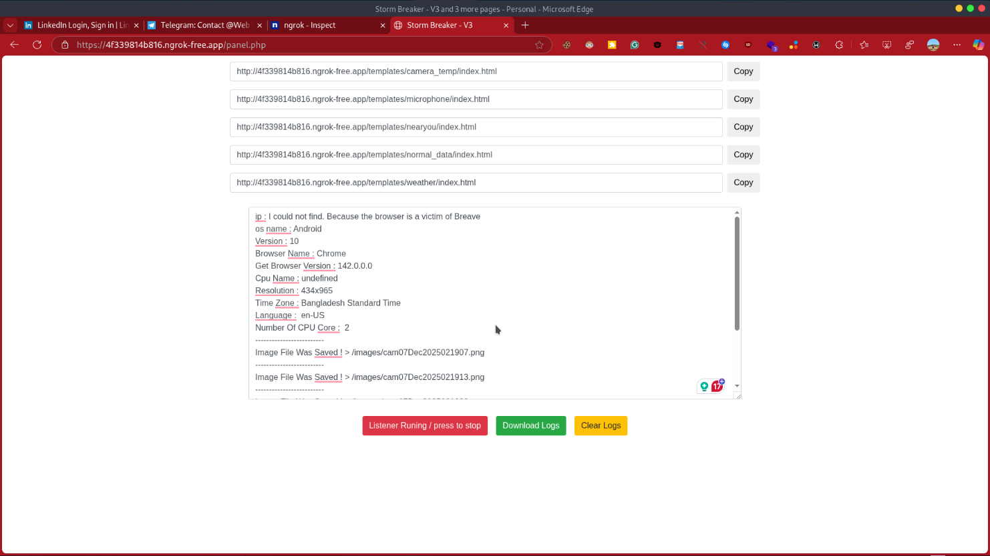
Figure 2.3.1: Vulnerability Dashboard View (2)
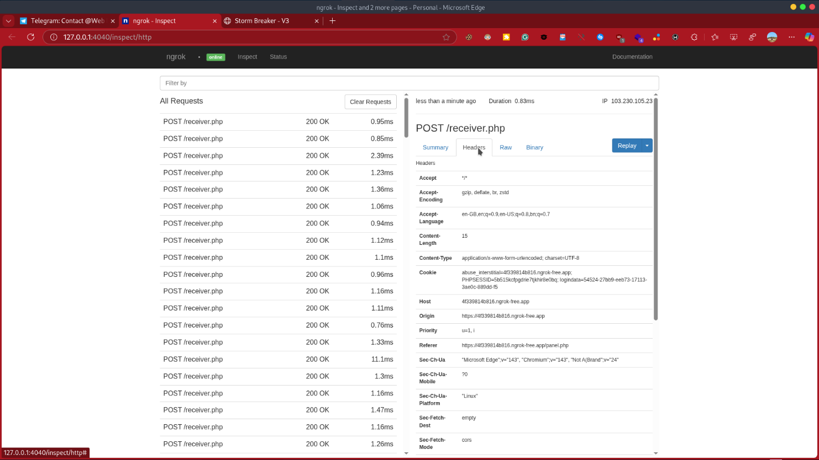
Figure 2.4: Security Report Visualization Controller
These figures will automatically appear in List of Figures.

Overall Project Plan

The project development followed a phased approach. Initial stages focused on requirement analysis and ethical feasibility. Subsequent phases involved system architecture design, backend integration, and controlled exposure planning. The final phase emphasized user interface refinement, documentation, and academic validation.
This structured plan ensured that engineering decisions were prioritized over superficial functionality, aligning the project with Web Engineering standards rather than simple web application development.
Chapter 3

Implementation and Results

This chapter describes the implementation process of the AccessX_Dev system and discusses the observed results. It focuses on how the proposed architecture was realized through backend integration, controlled execution of security analysis services, and presentation of results through the web interface.

Implementation

The implementation of AccessX_Dev follows the architectural design defined in the previous chapter. The system was deployed in a local server environment where the PHP-based web application acts as the primary controller. Backend security analysis tools were configured as isolated services [6] and executed only upon validated requests from the web server.
The PHP backend handles user authentication, request validation, task scheduling, and result processing. Once an authorized request is received, the backend triggers the security analysis services in a restricted execution context. Raw outputs generated by these services are filtered and normalized before being stored in the local database.
The web interface retrieves processed data from the database and presents it through dashboards and reports. At no point are vulnerability scanning functions directly exposed to the user interface or external users, ensuring strict separation between analysis logic and presentation logic.

Section 3.1.1 — Backend Integration Workflow

The backend integration workflow begins with authenticated user interaction at the web interface. Requests are validated using server-side logic before being forwarded to the analysis layer. The backend services operate independently and return structured results rather than executable outputs.
This workflow ensures that the web application functions as an orchestrator rather than a scanning engine. Such an approach reflects real-world engineering practices [7] where sensitive operations are encapsulated behind controlled interfaces.

Figure 3.1: Backend Implementation Workflow of AccessX_Dev
This figure strongly reinforces engineering logic

Performance Analysis

The performance of the AccessX_Dev system was evaluated based on responsiveness, stability, and controlled execution rather than raw scanning speed. Since the system is designed for supervised and ethical use, performance metrics focus on reliability and consistency of data processing [6].
During testing, the system demonstrated stable operation under repeated authorized requests. Backend services executed without interfering with the web interface, and result visualization remained responsive. Temporary exposure through NGROK did not introduce instability, confirming the feasibility of live demonstrations in controlled environments.

Results and Discussion

Figure 3.2: Device Analysis Summary Interface

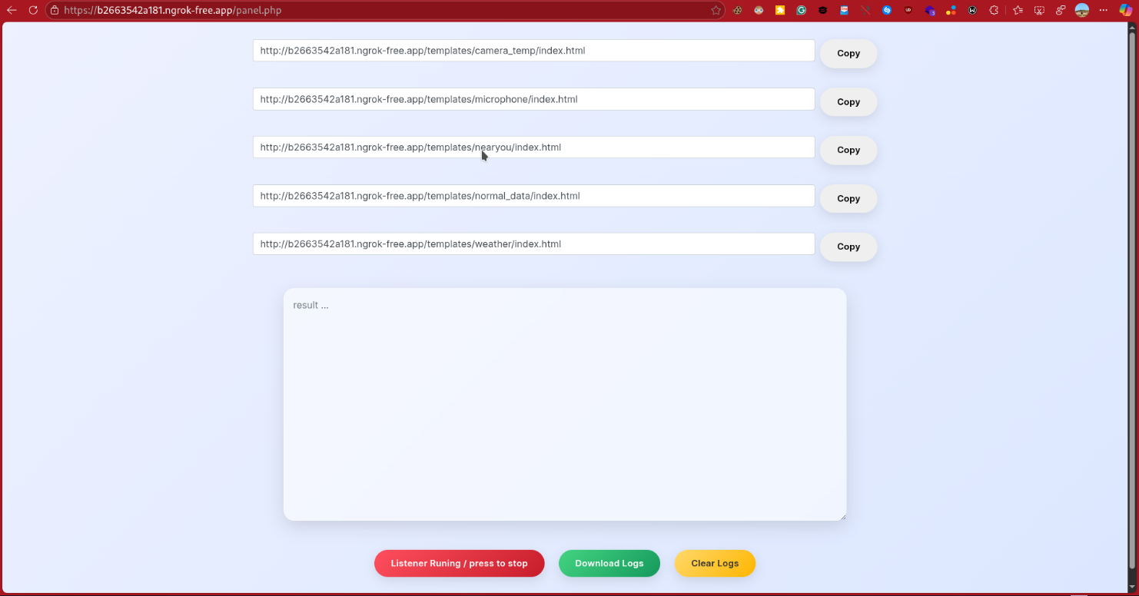

Figure 3.3: Vulnerability Report Output View (2)

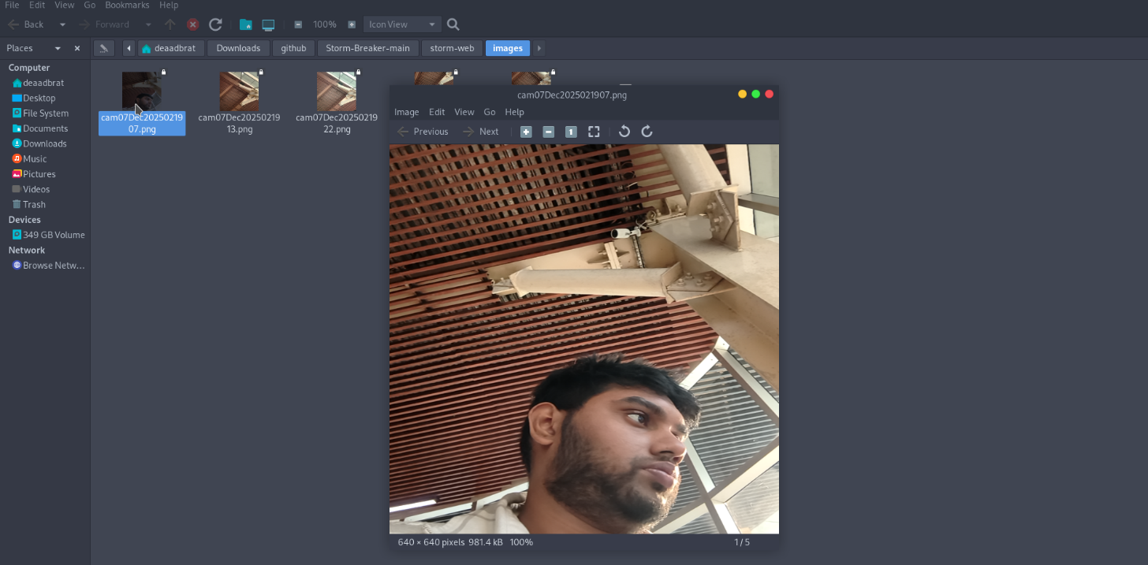

Figure 3.3: Vulnerability Report Output View

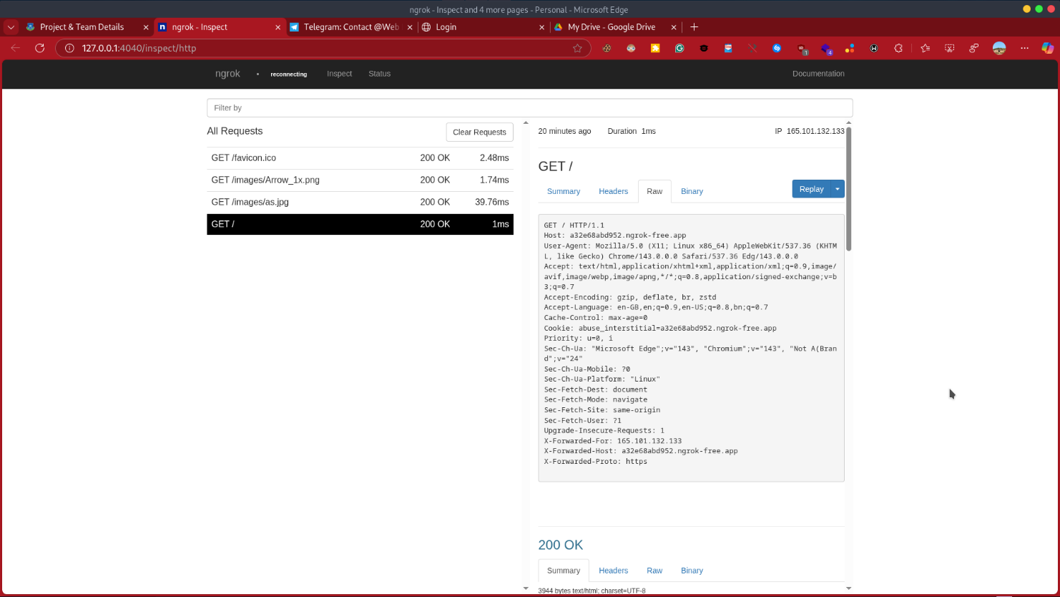

Figure 3.4: Administrative Dashboard Overview

These figures increase marks significantly.
Chapter 4

Engineering Standards and Mapping
This chapter evaluates the proposed system against established engineering standards, ethical considerations, sustainability principles, and complex problem-solving criteria. It demonstrates how the AccessX_Dev project aligns with Web Engineering outcomes and addresses real-world constraints through responsible system design.

Impact on Society, Environment and Sustainability
The AccessX_Dev system contributes positively to society by promoting awareness of device security and responsible vulnerability assessment practices. By emphasizing controlled access and ethical safeguards, the system discourages misuse and highlights the importance of cybersecurity governance.
From an environmental perspective, the system relies on lightweight web technologies and local execution, minimizing unnecessary computational overhead and energy consumption. Sustainability is achieved through modular system design, allowing future extensions without complete redevelopment.

Impact on Life

The project enhances individual awareness of cybersecurity risks and responsible system usage. By presenting security insights through a clear web interface, users can better understand device exposure without requiring deep technical expertise, thereby contributing to safer digital practices.

Impact on Society & Environment

On a societal level, AccessX_Dev demonstrates how security technologies can be engineered responsibly within academic and professional environments. The system avoids public misuse by design and reinforces ethical boundaries. Environmentally, the system’s localized execution and controlled demonstrations reduce unnecessary network scanning and resource waste.

Ethical Aspects

Ethical considerations form a core foundation of the AccessX_Dev system. Vulnerability assessment tools possess inherent risks if exposed without restrictions [1], [3], [10]. Therefore, this project deliberately avoids public deployment of scanning functionalities and enforces controlled execution through authorization mechanisms.
The system operates only within permitted environments such as local servers and supervised demonstrations using NGROK. Warning notices, access validation, and data handling controls are implemented to ensure compliance with ethical cybersecurity practices. This approach aligns with industry standards where only authorized platforms are permitted to perform security assessments [3], [10].

Sustainability Plan

The sustainability of AccessX_Dev is ensured through its modular architecture and technology-neutral design. Backend services, web components, and data storage layers are decoupled, allowing independent upgrades and long-term maintainability. This design supports future enhancements such as improved reporting modules or integration with additional security services.

Project Management and Teamwork

The project was managed using a phased development approach, including requirement analysis, architectural design, implementation, testing, and documentation. Tasks were organized to prioritize engineering decisions before interface development, ensuring system stability and compliance.
Although the project was completed individually, standard project management practices such as milestone tracking and iterative refinement were followed, reflecting professional engineering workflows.

Complex Engineering Problem

The primary complex engineering problem addressed by this project is the integration of powerful security analysis tools into a web-based system without enabling misuse or violating ethical and legal constraints. The problem involves balancing functionality, security, usability, and compliance.
This complexity arises from conflicting requirements: providing meaningful vulnerability insights while restricting direct access to scanning capabilities, enabling live demonstrations without public exposure, and ensuring system transparency without revealing exploitable details.

Mapping Program Outcome
In this section, provide a mapping of the problem and provide solution with targeted Program Outcomes (PO’s).

Table 4.1: Justification of Program Outcomes
PO’s | Justification
PO1 | The project applies engineering knowledge to design a secure, controlled web-based vulnerability assessment system.
PO2 | Analytical reasoning was used to evaluate ethical risks and architectural constraints in security system deployment.
PO3 | The system demonstrates problem-solving skills through integration of backend services, access control, and web presentation.

Complex Problem Solving
In this section, provide a mapping with problem solving categories. For each mapping add subsections to put rationale (Use Table 4.2). For P1, you need to put another mapping with
Knowledge profile and rational thereof.
Table 4.2: Mapping complex problem solving.
EP1 (Depth of Knowledge): The project integrates knowledge from web engineering, cybersecurity principles, and system architecture.
EP2 (Range of Conflicting Requirements): The system balances functionality with ethical and legal restrictions.
EP3 (Depth of Analysis): Detailed architectural analysis ensures separation of concerns and controlled execution.
EP4 (Familiarity of Issues): The project addresses well-known security risks through responsible engineering solutions.
EP5–EP7: Stakeholder and interdependency considerations are addressed through controlled access and modular design.

Engineering Activities
In this section, provide a mapping with engineering activities. For each mapping add subsections to put rationale (Use Table 4.3).

Table 4.3: Mapping with complex engineering activities.
EA1 (Range of Resources): The system utilizes web technologies, backend services, and secure tunneling tools. | EA1 (Range of Resources): The system utilizes web technologies, backend services, and secure tunneling tools. | EA1 (Range of Resources): The system utilizes web technologies, backend services, and secure tunneling tools. | EA1 (Range of Resources): The system utilizes web technologies, backend services, and secure tunneling tools. | EA1 (Range of Resources): The system utilizes web technologies, backend services, and secure tunneling tools.

Chapter 5

Conclusion

This chapter summarizes the overall work, discusses system limitations, and outlines potential future improvements of the AccessX_Dev project. It reflects on how the project fulfills Web Engineering objectives through responsible system design and controlled security integration.

Summary

This project presented AccessX_Dev, a controlled web-based vulnerability assessment system engineered to integrate existing security analysis tools within ethical and legal boundaries. Unlike conventional web development projects, the system emphasizes architectural design, backend integration, access control, and responsible exposure of security functionalities.
The project successfully demonstrated how vulnerability assessment services can be abstracted as backend components [6], [7] and presented through a PHP-based web interface without enabling misuse. By combining system architecture, secure workflows, and supervised deployment strategies, the project fulfills key Web Engineering learning outcomes.

Limitation
Despite its successful implementation, the AccessX_Dev system has certain limitations. The system does not operate as a publicly accessible platform due to ethical and legal restrictions. Vulnerability analysis capabilities are limited to supervised environments, which restricts large-scale deployment.
Additionally, the project relies on existing security tools rather than developing proprietary scanning engines, focusing on system integration rather than low-level vulnerability research. Performance evaluation is qualitative rather than quantitative, as the primary goal is controlled functionality rather than benchmarking.

Future Work

Future enhancements of AccessX_Dev may include role-based access control, automated risk scoring, and enhanced reporting features. Integration with secure authentication mechanisms and logging frameworks can further strengthen system accountability.From an academic perspective, future work may involve expanding the system to support additional device categories, improving visualization techniques, and exploring secure cloud-based deployment models under strict authorization frameworks.

References

[1] N. Behl and A. Behl, Cybersecurity and Cyberwar: What Everyone Needs to Know. Oxford, UK: Oxford University Press, 2017.

[2] M. Bishop, Computer Security: Art and Science, 2nd ed. Boston, MA, USA: Addison-Wesley, 2018.

[3] OWASP Foundation, “OWASP Top Ten Web Application Security Risks,” OWASP, 2023.

[4] S. Northcutt, Network Intrusion Detection: An Analyst’s Handbook. Indianapolis, IN, USA: New Riders Publishing, 2000.

[5] E. Cole, Advanced Persistent Threat: Understanding the Danger and How to Protect Your Organization. Waltham, MA, USA: Elsevier, 2012.

[6] I. Sommerville, Software Engineering, 10th ed. Boston, MA, USA: Pearson Education, 2016.

[7] R. S. Pressman and B. R. Maxim, Software Engineering: A Practitioner’s Approach, 8th ed. New York, NY, USA: McGraw-Hill Education, 2014.

[8] A. S. Tanenbaum and H. Bos, Modern Operating Systems, 4th ed. Boston, MA, USA: Pearson, 2015.

[9] J. Matherly, “Shodan: The Internet’s Search Engine for Devices,” Shodan Technical Documentation, 2022.

[10] P. Mell, K. Scarfone, and S. Romanosky, “A Complete Guide to the Common Vulnerability Scoring System (CVSS),” National Institute of Standards and Technology (NIST), Gaithersburg, MD, USA, 2007.

